ANU Comp 3100

Developer security training as a service

Project Planning Draft

Lin Zhou (u5770983)

Yu Xia (u6134682)

Runze (u5454208)

Zongge (u5431907)

Contents

What is this project? 3

Product Vision (Client) 3

Team Goals 3

Scopes 3

Team Members Roles & responsibilities 4

Communication Environment 4

Application environment 4

Schedules 4

User story map 6

Iteration 7

First iteration : automated deployment of app 7

Second Iteration: automated grading 7

Third Iteration: embed training materials 7

Fourth Iteration: authentication, billing, reporting 7

Release Plan 8

# What is this project?

Developer Security Training As a Service is a web base online platform that enhance developer with skills to identify, exploit and resolve application security vulnerabilities. This platform is not only performing penetration tests for applications but also provide resources and trainings to identify those vulnerabilities. Thus, this platform include multiple features such as online study, penetration test, forums for discussion and grading system etc.This project will help software engineer reduced code error or potential vulnerable code during development. Increasing their security awareness and decreasing chance of being attacked. Furthermore, this project is initial by David Jorm who is an expert of Information security industry. He will guide us throughout the project, and share knowledge with development team.

# Product Vision (Client)

Most software products handle security vulnerabilities on a reactive basis - when a vulnerability it is all hands on deck to ship a patch and associated documentation. However, proactive efforts to reduce the number of vulnerabilities that enter the code base in the first place are generally limited to major products from multi-national vendors. Limited empirical evidence shows that training developers in offensive security (i.e. penetration testing) drastically reduces the number and severity of vulnerabilities in their code. Delivering this training face to face, with manual delivery and assessment of hands on activities, is expensive and impossible to scale. The goal of this project is to automate delivery of training and assessment of hands on penetration testing exercises in a SaaS platform, which can scale, and allow smaller software vendors and projects to train their developers in an affordable fashion.

# Team Goals

1. Keep this project finishing on time
2. Learn from each other after each sprint
3. Working as a team to achieve all requirements
4. Working with every task effectively

# Scopes

Based on the requirements, the project should accomplish the web base platform that allow users learn application vulnerabilities online. This is including the course material (PPT, Word, PDF) that available within the platform. Further, the web base platform is able to perform penetration test if the users would like to give a try and a grading system that must able to give the grade base on the penetration task that users complete. And a forum discussion page will allow users to post their question for discussion.

# Team Members Roles & responsibilities

|  |  |  |
| --- | --- | --- |
| Name | Role | Responsivities |
| David Jorm | Client & stakeholder | Provide project requirements for each iteration. Review the team performance. Give feedback of the project. Monitoring the project. |
| Yu Xia | Team Leader | Call for meeting, provide burn up chart every week, keep track of project schedule. manage team member relationship, coding and transform the project requirement into user story map. Divide the requirement into tasks and assign to team members. Report problem and bottlenecks to clients and stakeholder. Search for solutions of those problem. Debugging |
| Lin Zhou | Developer | Build framework. Configure EC2 and web App. Java coding. HTML coding. Search for tutorial and share knowledge. Interface design. Report problem to Team Leader. Debugging |
| Runze Liu | Developer | Build framework. Java coding. HTML coding. Interface design. Report problem to Team Leader. Debugging |
| Zongge Ren | Developer | VM configure. tomcat configure. Java coding. HTML coding. Report problem to Team Leader. Debugging |

# Communication Environment

|  |  |
| --- | --- |
| **Purpose** | **Tools** |
| Team Communication | WeChat Group or Phone call |
| Client Communication (report problem) | Whatsapp Group |
| Client Communication (Documentation and requirement) | Email, Google Drive |
| Meeting | Skype or physical location at ANU CSIT N110 |

# Application environment

|  |  |
| --- | --- |
| **Functions** | **Tools** |
| Web Server | Amazon EC2 Web application |
| Server | VM (Ubuntu), running Tomcat server |
| Web Interface | HTML |

# Schedules

|  |  |  |  |
| --- | --- | --- | --- |
| Event | Date | Time | Purpose |
| Project start | 1/8/2016 |  |  |
| Project end | 16/6/2017 |  |  |
| Client Meeting | Every Monday | 3:30 PM – 4:30 PM | Getting Specific Requirements and report progress |
| Client Meeting | Every Friday | 4:30 PM – 5:30 PM | Report progress and report problem if applicable |
| Team Meeting | Every Monday | 4:30 PM – 5:30 PM | Transform requirements into tasks and assign task to team members |
| Tutor Meeting | Thursday, Once of two weeks. Start from 11/8/2016 | 3 PM – 4 PM | Grading for progress and learning outcome |

# User story map

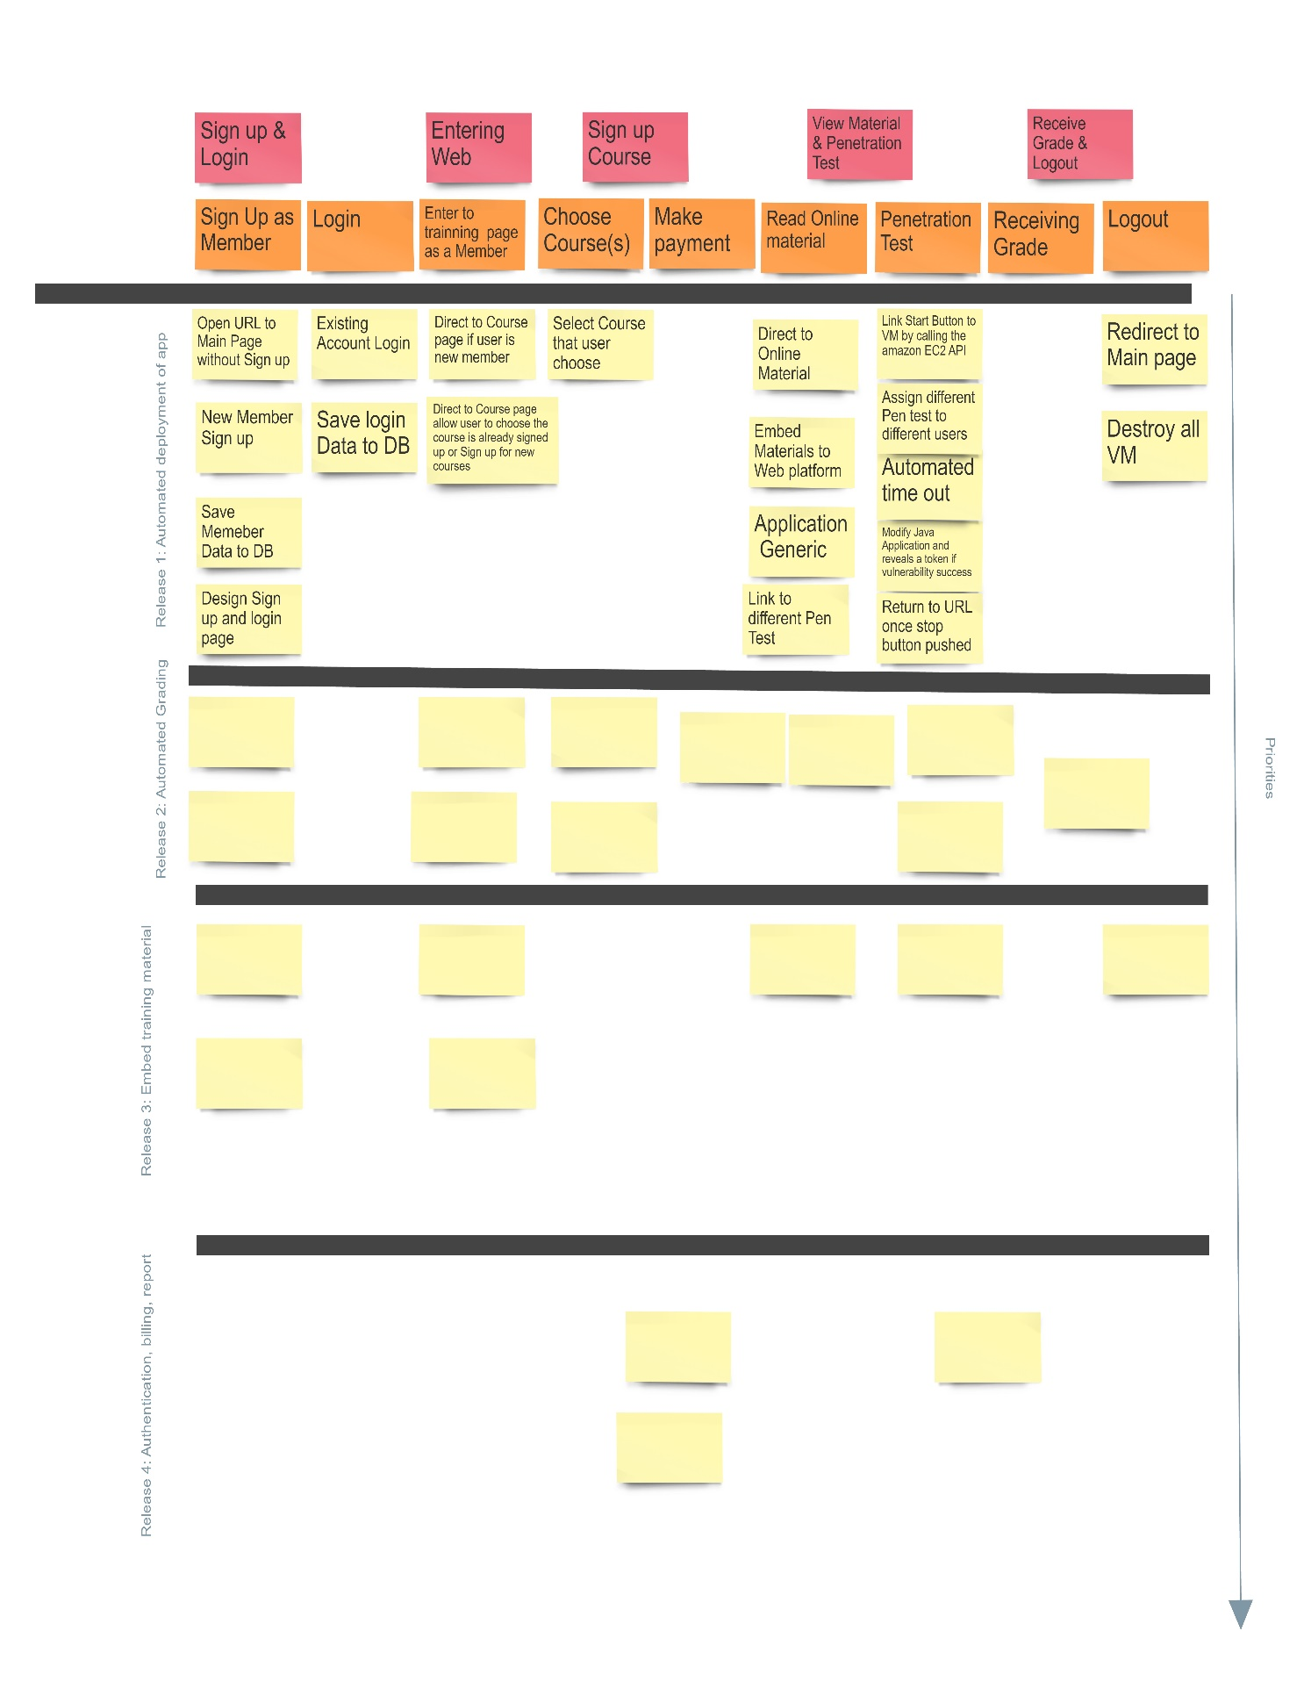

# Iteration

## First iteration : automated deployment of app



## Second Iteration: automated grading

## Third Iteration: embed training materials

## Fourth Iteration: authentication, billing, reporting

# Release Plan